**19 AUG 2020 IPTABLES**

**Sever**

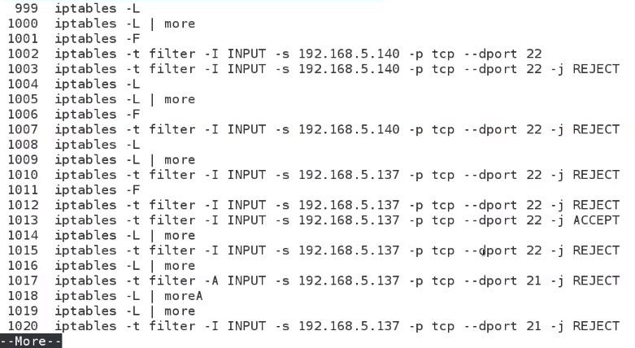

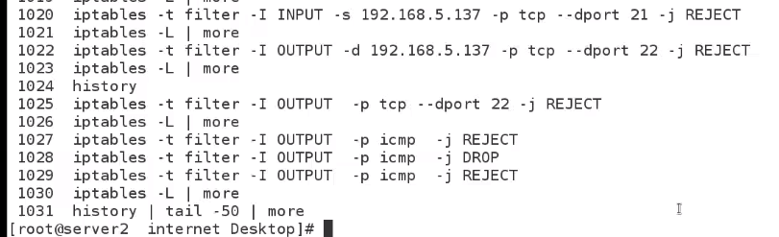

**Lab**

**Server**

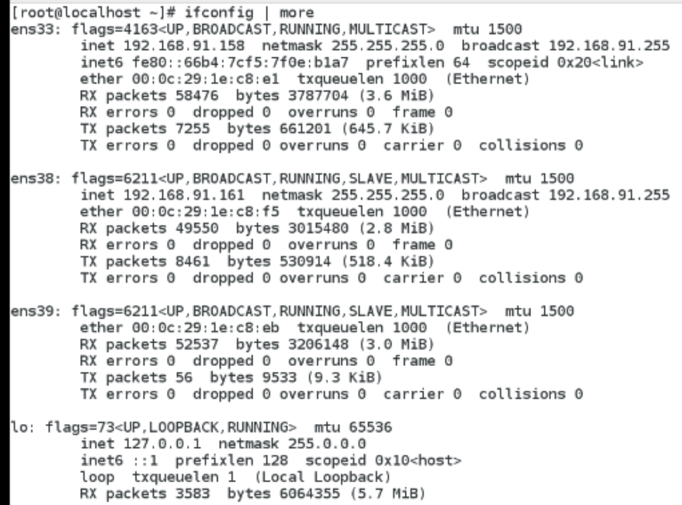

**client**

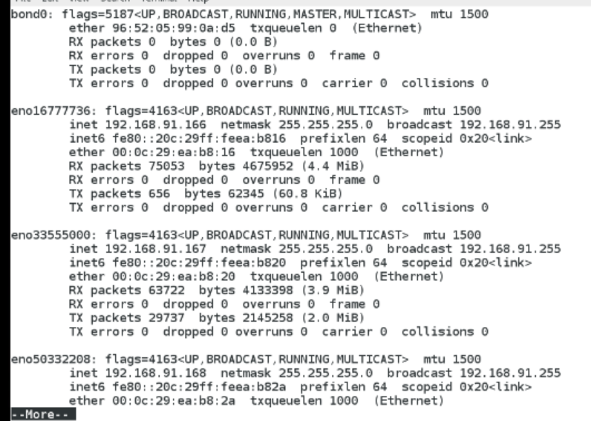

**Server**

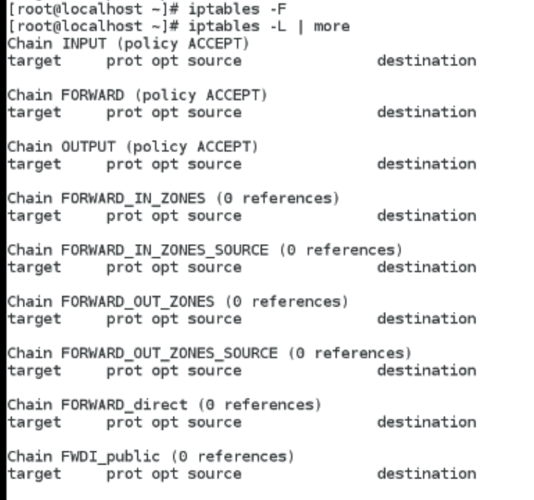

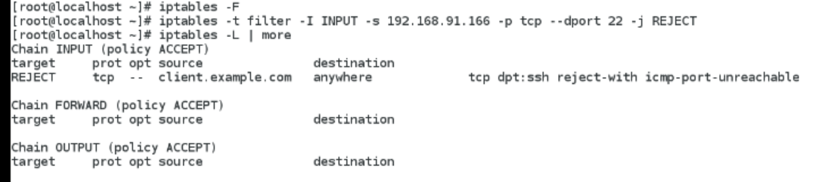

**From client**

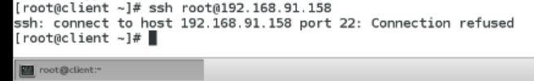

**From server**

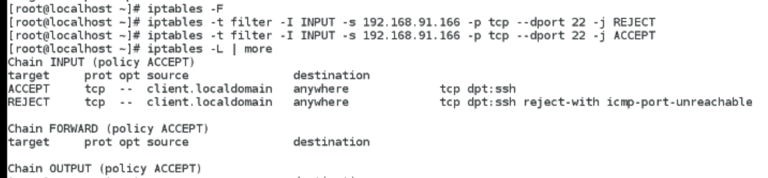

**Client**

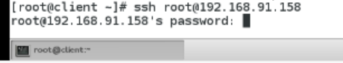

**Server**

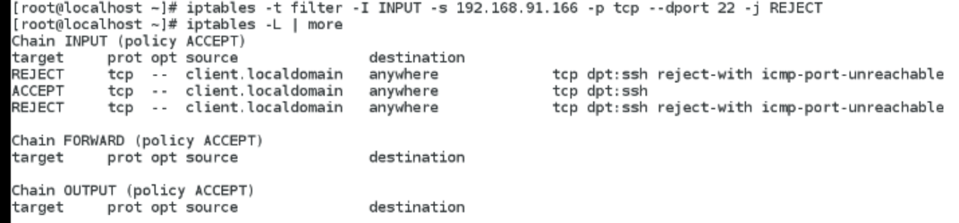

**From client**



**server**

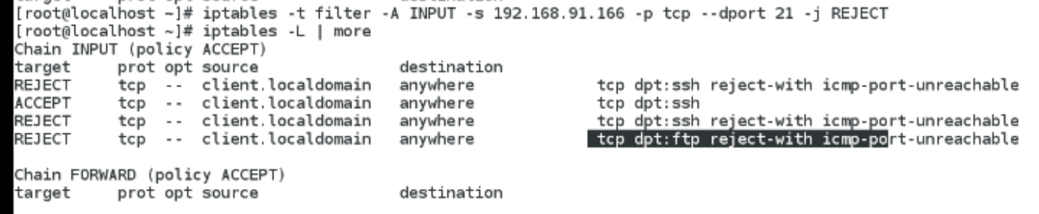

**Server side ssh client ip terminal 2**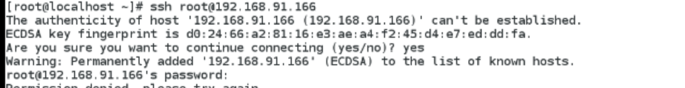

**Server side terminal 1**

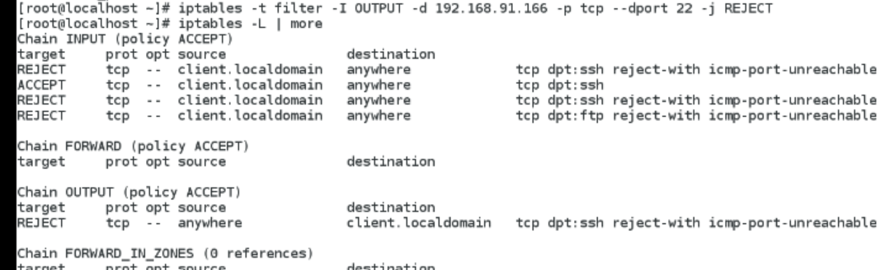

**Server terminal 2**

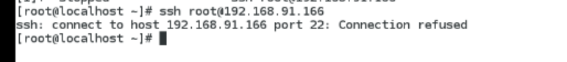

**Serverside terminal 1**

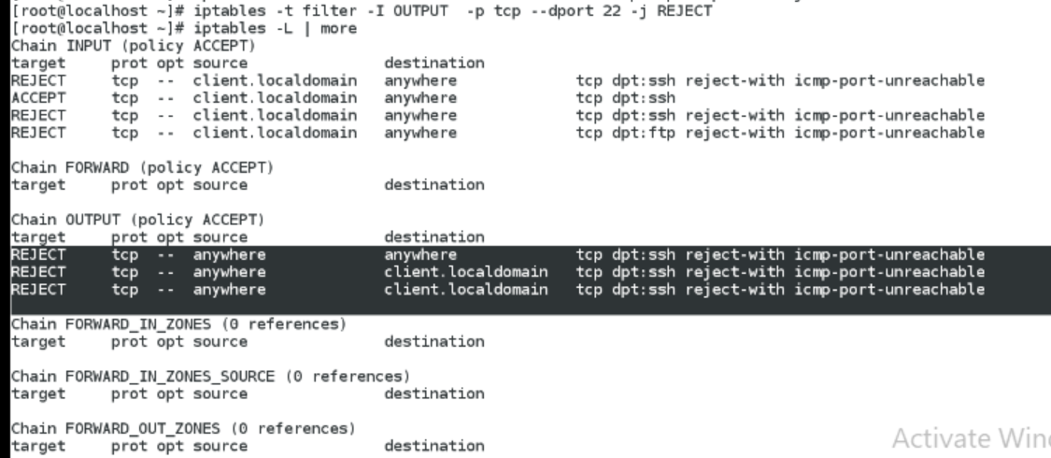

**Server Terminal 1**

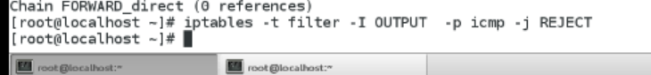

**Server Terminal 2**

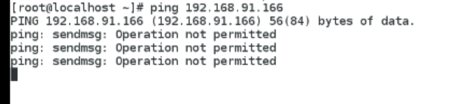

**After drop & reject**

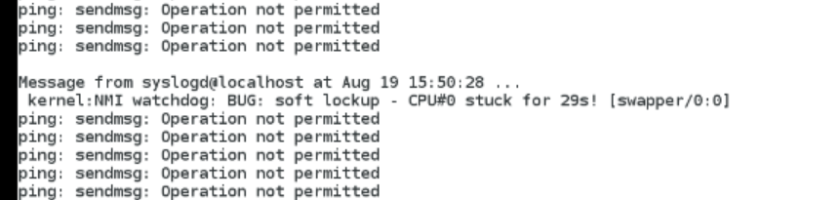

**Server Terminal 1**

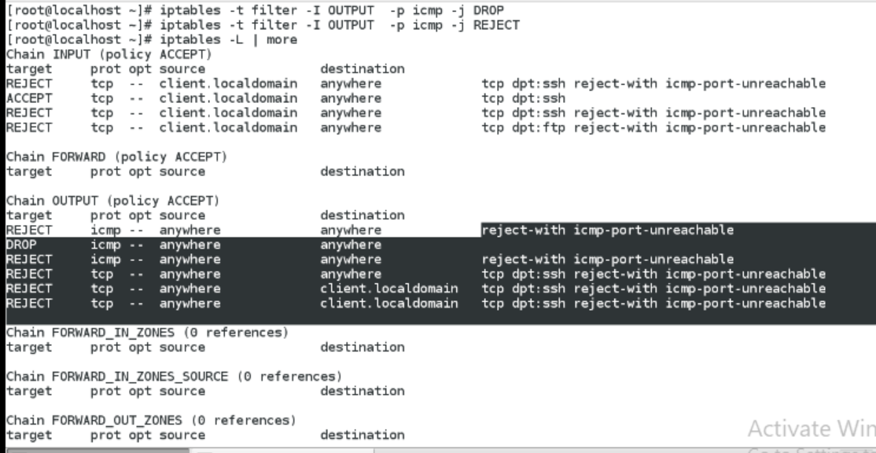

**Afternoon firewallD - history**

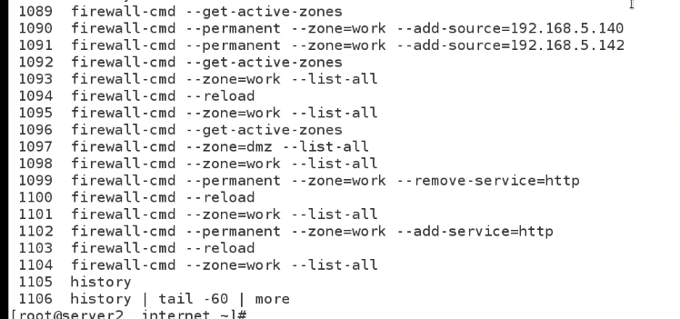

**To create web page**

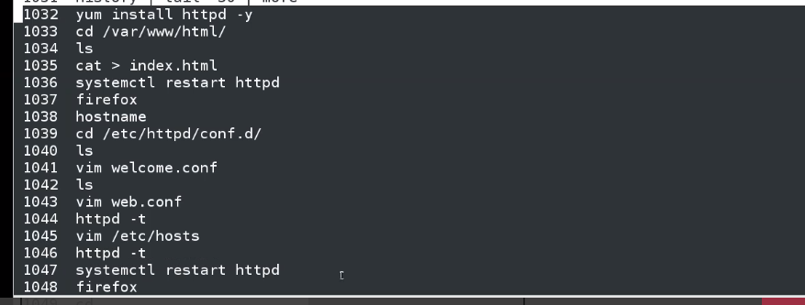

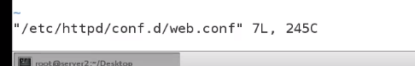

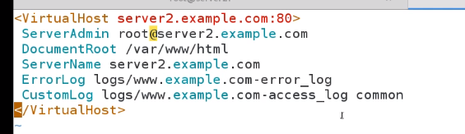

**Lab**

**Yum install httpd –y**

